**Half-a-day Quick Knowledge Mining Workshop**

The objective is to allow the business user or data engineer a quick way to show their management the power of Azure Search in a ready made application.

Prerequisites:

* Windows 10
* Azure Subscription and connectivity
* PowerShell

1. Start the session with a presentation what is Azure search - What is  [azure search](https://docs.microsoft.com/en-us/azure/search/search-what-is-azure-search)  presentation.
2. Have client install Intelligent Kiosk – custom viewer if they have access to MS Azure Subscription. Note this has a prerequisite of Windows 10,

<http://aka.ms/kioskapp> . The point is to use some of the apps in kiosk to support presentation.

1. Demonstrate the creation of an Azure Cognitive search service from the portal
2. Introduce the Knowledge mining   accelerator tool and demonstrate. The message here is that you can bring this after the workshop to your executives to demo with some of your own documents, and be able to compare the productivity gains here on the abstraction tool created.
3. Install <https://aka.ms/kma>  - Azure search tool uses Azure search services  and cognitive search
   1. View video on top RHS when you invoke one of the scenarios

To customize the tool see the “ ***create your own deployment***”  –

you can add you documents here from a blank slate and change the logo of the picture to your company

* 1. Ask your comrades for a windows machine if you have to customize this for your documents
  2. Install is easy if you have Powershell installed I was able to follow well.
  3. You will need access a VPN in Azure
  4. Please use a windows machine with Powershell

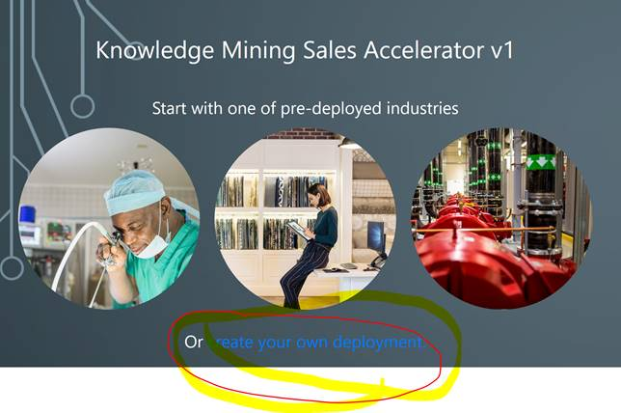

1. Introduction  to Git of JFK – demo and Git. As a take home have the client access the JFK files and demonstrate it in class.
   1. Note you will need to lecture a bit *what is customs skills* here and where they need additional training on
      1. The idea is not to do this in class but for them to take home the source code.

* 1. Source code of JFK on git – <https://github.com/microsoft/AzureSearch_JFK_Files>

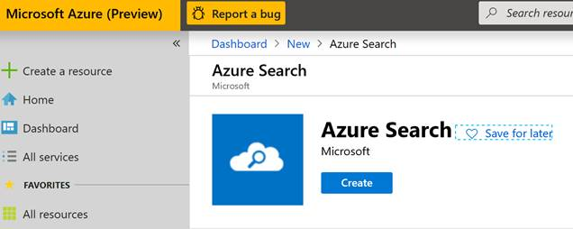

* 1. Azure search on portal – top create a search service endpoint

1. Request for private preview – Forms Recognizer Version2  - separate email . Should this be a topic that comes up.